Q1a.

Output:

[[[('1', '4', '5'), ('1', '4', '8'), ('4', '7', '8')], [[('1', '2', '4'), ('4', '5', '7')], [('1', '2', '5'), ('1', '5', '8')], [('1', '2', '3'), ('1', '5', '9'), (Linked List() - 1')]], [('1', '3', '6'), ('4', '6', '7'), ('1', '3', '8')]], [[('2', '4', '8')], [('2', '5', '9')], [('2', '3', '4'), ('2', '3', '6'), ('2', '6', '8')]], [[[], [('3', '4', '5'), ('3', '7', '8')], [('3', '4', '6'), ('6', '7', '9')]], [[], [], [('3', '5', '6'), ('3', '5', '9'), (Linked List() - 0')]], [('3', '6', '8')]]]

Linked list details:

1': ('1', '2', '6')->{('1', '8', '9')}

0': ('3', '8', '9')->{('6', '8', '9')}

Q1b.

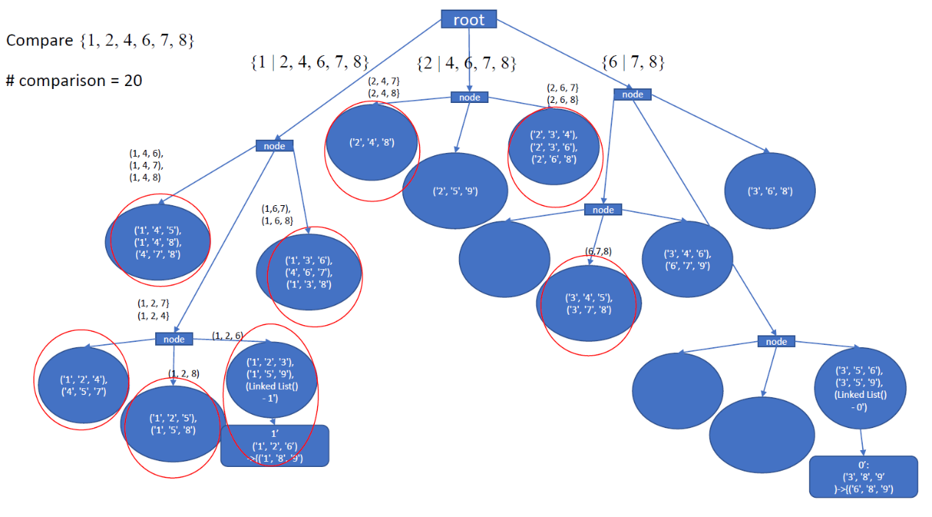

\*\* For clearer picture, please refer to Q1b.pdf

The number of comparisons to be 20, as the number of comparisons to be the numbers of data in hash node. Therefore, the total numbers of comparison be 20.

Q2a.

(Milk) : 5526

(Ghee) : 5510

(Coffee Powder) : 5509

(Yougurt) : 5503

(Bread) : 5484

(Sweet) : 5483

(Sugar) : 5482

(Butter) : 5481

(Cheese) : 5476

(Panner) : 5444

(Lassi) : 5432

(Tea Powder) : 5383

(Coffee Powder,Ghee) : 2578

(Lassi,Sweet) : 2576

(Butter,Sugar) : 2571

(Sugar,Milk) : 2563

(Yougurt,Coffee Powder) : 2555

(Panner,Bread) : 2550

(Butter,Sweet) : 2543

(Sweet,Bread) : 2539

(Lassi,Milk) : 2539

(Cheese,Yougurt) : 2532

(Butter,Ghee) : 2530

(Cheese,Bread) : 2530

(Sugar,Yougurt) : 2529

(Butter,Yougurt) : 2529

(Bread,Coffee Powder) : 2528

(Panner,Ghee) : 2523

(Coffee Powder,Milk) : 2518

(Bread,Milk) : 2517

(Cheese,Coffee Powder) : 2517

(Sugar,Ghee) : 2516

(Yougurt,Milk) : 2513

(Sweet,Milk) : 2512

(Lassi,Coffee Powder) : 2512

(Ghee,Milk) : 2511

(Lassi,Ghee) : 2511

(Bread,Yougurt) : 2507

(Lassi,Bread) : 2506

(Panner,Sugar) : 2505

(Panner,Sweet) : 2505

(Sweet,Ghee) : 2504

(Bread,Ghee) : 2503

(Sugar,Coffee Powder) : 2503

(Lassi,Sugar) : 2503

(Tea Powder,Sweet) : 2503

(Butter,Coffee Powder) : 2502

(Lassi,Butter) : 2501

Q2b.

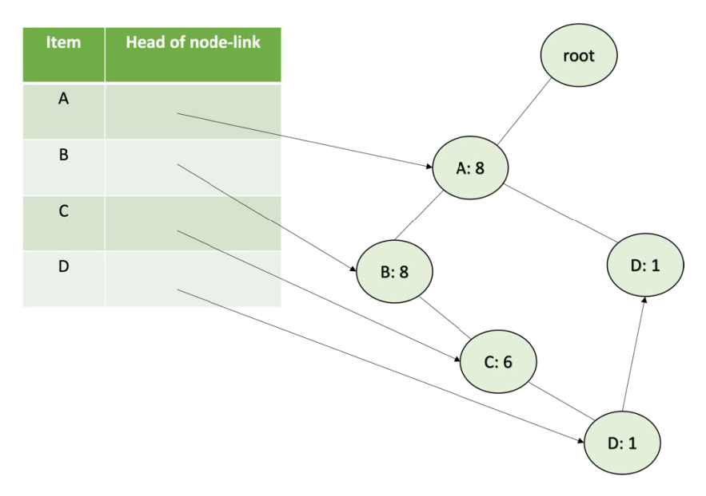

Conditiona FP-Tree on D

[{a:1, b:1, c:1, d:1},

{a:1, d:1}]

With Support Threshold 2, Conditional Pattern Base

[{a:1, d:1},

{a:1, d:1}]